ABSTRACT
Once an application steps out of the bounds of a single-computer box, its external communication is immediately exposed to a multitude of outside observers with various intentions, good or bad. In order to protect sensitive data while these are en route, applications invoke different methods. In today's world, most of the means of secure data and code storage and distribution rely on using cryptographic schemes, such as certificates or encryption keys. Thus, cryptography mechanisms form a foundation upon which many important aspects of a solid security system are built. Cryptography is the science of writing in secret code and is an ancient art. Some experts argue that cryptography appeared spontaneously sometime after writing was invented, with applications ranging from diplomatic missives to war-time battle plans. It is no surprise, then, that new forms of cryptography came soon after the widespread development of computer communications. There are two basic types of cryptography: Symmetric Key and Asymmetric Key. Symmetric key algorithms are the quickest and most commonly used type of encryption. Here, a single key is used for both encryption and decryption. There are few well-known symmetric key algorithms i.e. DES, RC2, RC4, IDEA etc. This synopsis describes cryptography, various symmetric key algorithms in detail and then proposes a new symmetric key algorithm. Algorithms for both encryption and decryption are provided here. The advantages of this new algorithm over the others are also explained.

- Introduction
Does increased security provide comfort to paranoid people? Or does security provide some very basic protections that we are naive to believe that we don't need? During this time when the Internet provides essential communication between tens of millions of people and is being increasingly used as a tool for commerce, security becomes a tremendously important issue to deal with. There are many aspects to security and many applications, ranging from secure commerce and payments to private communications and protecting
passwords. One essential aspect for secure communications is that of Cryptography. The concept of securing messages through cryptography has a long history. Indeed, Julius Caesar is credited with creating one of the earliest cryptographic systems to send military messages to his generals. "Cryptography" derives from the Greek word “kruptos”, meaning "hidden". The key to hiding data is to devise a hiding (encryption) mechanism that is very difficult to reverse (i.e., to find the original data) without using the decryption key. Usually, the harder it is to discover the key, the more secure the mechanism. In symmetric (also called "secret-key" and, unfortunately, "private key") encryption, the same key (or another key fairly easily computed from the first) is used for both encryption and decryption. In asymmetric (also called "public-key") encryption, one key is used for encryption and another for decryption. A new Symmetric Key cryptographic algorithm has been proposed in this synopsis with its advantages and disadvantages.

- History of Cryptography
Cryptography, the science of encrypting and decrypting information, dates as far back as 1900 BC when a scribe in Egypt first used a derivation of the standard hieroglyphics of the day to communicate.
There are many notable personalities who participated in the evolution of Cryptography

3. Purpose of Cryptography
In a typical situation where cryptography is used, two parties (X and Y) communicate over an insecure channel. X and Y want to ensure that their communication remains incomprehensible by anyone who might be listening. Furthermore, because X and Y are in remote locations, X must be sure that the information she receives from Y has not been modified by anyone during transmission. In addition, she must be sure that the information really does originate from Y and not someone impersonating Y. Cryptography is used to achieve the following goals:
Confidentiality: To ensure data remains private. Confidentiality is usually achieved using encryption. Encryption algorithms (that use encryption keys) are used to convert plain text into cipher text and the equivalent decryption algorithm is used to convert the cipher text back to plain text. Symmetric Encryption algorithms use the same key for encryption and decryption, while asymmetric algorithms use a public/private key pair.
Data integrity: To ensure data is protected from accidental or deliberate (malicious) modification. Integrity is usually provided by message authentication codes or hashes. A hash value is a fixed length numeric value derived from a sequence of data. Hash values are used to verify the integrity of data sent through insecure channels. The hash value of received data is compared to the hash value of the data as it was sent to determine if the data was altered.
message. Contrast this with public-key cryptology, which utilizes two keys - a public key to encrypt messages and a private key to decrypt them. Symmetric-key systems are simpler and faster, but their main drawback is that the two parties must somehow exchange the key in a secure way. Public-key encryption avoids this problem because the public key can be distributed in a Non-secure way, and the private key is never transmitted. Symmetric-key cryptography is sometimes called secret-key cryptography. The most popular symmetric-key system is the Data Encryption Standard (DES).

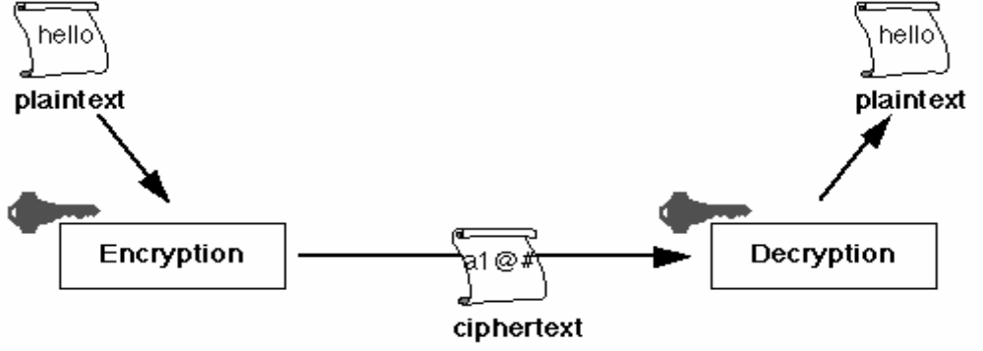
.

(Fig 1.symmetric encryption)
In secret key cryptography, a single key is used for both encryption and decryption. As shown in Fig. 1, the sender uses the key (or some set of rules) to encrypt the plaintext and sends the cipher text to the receiver. The receiver applies the same key (or rule set) to decrypt the message and recover the plaintext. Because a single key is used for both functions, secret key Cryptography is also called symmetric encryption. With this form of cryptography, it is obvious that the key must be known to both the sender and the receiver; that, in fact, is the secret. The biggest difficulty with this approach, of course, is the distribution of the key.

4. Types of Cryptography

Cryptography is a process which is associated with scrambling plaintext (ordinary text, or clear text) into cipher text (a process called encryption), then back again (known as decryption). There are several ways to classify the various algorithms. The most common types are 1) Secret Key Cryptography which is also known as ‘Symmetric Key Cryptography’ and 2) Public Key Cryptography which is also known as ‘Asymmetric Key Cryptography’.

Secret Key Cryptography: In secret key cryptography, a single key is used for both encryption and decryption. The sender uses the key (or some set of rules) to encrypt the plaintext and sends the cipher text to the receiver. The receiver applies the same key (or rule set) to decrypt the message and recover the plaintext. Because a single key is used for both functions, secret key cryptography is also called symmetric encryption. With this form of cryptography, it is obvious that the key must be known to both the sender and the receiver; that, in fact, is the secret. The biggest difficulty with this approach, of course, is the distribution of the key.

Public Key Cryptography: Public or asymmetric key cryptography involves the use of key pairs: one private key and one public key. Both are required to encrypt and decrypt a message or transmission. The private key, not to be confused with the key utilized in private key cryptography, is just that, private. It is not to be shared with anyone. The owner of the key is responsible for securing it in such a manner that it will not be lost or compromised. On the other hand, the public key is just that, public. Public key cryptography intends for public keys to be accessible to all users. In fact, this is what makes the system strong. If a person can access anyone public key easily, usually via some form of directory service, then the two parties can communicate securely and with little effort, i.e. without a prior key distribution arrangement.

5. Advantages

1. The encryption is very difficult to crack and is reliable.

2. The communicating pair is assured of complete security.

6. Disadvantages

1. Key distribution and management is extremely costly and tedious.

2. If the attacker comes to know about the secret key, then this cryptography is of no use.

7. Algorithm used-DES (Data Encryption Standard)
The Data Encryption Standard (DES) was developed by an IBM team around 1974 and adopted as a national standard in 1977. Since that time, many cryptanalysts have attempted to find shortcuts for breaking the system. In this synopsis, we examine one such attempt, the method of differential cryptanalysis, published by Balham and Shamir. We show some of the safeguards against differential cryptanalysis that were built into the system from the beginning, with the result that more than 10-15 bytes of chosen plaintext are required for this attack to succeed. Federal Information Processing Standards Publications (FIPS PUBS) are issued by the National Institute of Standards and Technology after approval by the Secretary of Commerce pursuant to Section 5131 of the Information Technology Management Reform Act of 1996 (Public Law 104-106), and the Computer Security Act of 1987 (Public Law 100-235).

Step 1: The 64-bit plain text block is handed over to an Initial Permutation function. The Initial Permutation is performed over the plain text block.
Step 2: The Initial Permutation [IP] produces two halves of the permuted block; say left block [LPT] and right block [RPT].
Step 3: Each of the LPT and RPT go through 16 rounds of encryption process.
Step 4: In the end, LPT and RPT are rejoined and a final Permutation [FP] combined block.
Step 5: The result of this process produces 64-bit cipher text.

(Fig 1.4 Algorithm of DES)
Plain text
Initial permutation
LPT
RPT
15 Rounds
15 Rounds
Final permutation
Cipher text
Step 1
Step 2
Step 3
Key
Key
Step 4
Step 5
Step 6

8. Conclusion
We understood briefly what Cryptography means and what its need is. We also understood briefly what the basic types of cryptography are. We understood briefly symmetric key cryptography which is implemented in our software. We understood briefly the previous work done by our team. We understood briefly the various problems that the existing cryptographic systems are facing. All the above mentioned problems are eliminated to a substantial level in our algorithm.

9. References

[1] “Basic Cryptographic Algorithms”, an article available at
www.itsc.state.md.us/oldsite/info/InternetSecurity/Crypto/
CryptoIntro.htm#Algorithms

[2] S. Hebert, “A Brief History of Cryptography”, an article
Available at http://cybercrimes.net/aindex.html

[3] “Introduction to Public-Key Cryptography”, an article
Available at
developer.netscape.com/docs/manuals/security/pkin/conte
nts.html

[4] D. Jablon, "Strong Password Only Authenticated Key
Exchange" Computer Communication Review, ACM
SIGCOMM, Vol 26 No 5, pp 5-26, 1997

[5] S. M. Bellovin and M. Merritt, "Augmented Encrypted Key
Exchange a Password Based Protocol Secure Against
Dictionary Attacks and Password File Compromise"
Proceedings of the First ACM Conference on Computer
[6] Mohammad Zakir Hossain Sarker and Md. Shafiul Parvez,
“A Cost Effective Symmetric Key Cryptographic Algorithm for Small Amount
Of Data” Department of CSE, East West University,
43, Mohakhali, Dhaka-1212, Bangladesh

